**Installing ESP32 Add-on in Arduino IDE**

To install the ESP32 board in your Arduino IDE, follow these next instructions:

1. In your Arduino IDE, go to **File**> **Preferences**

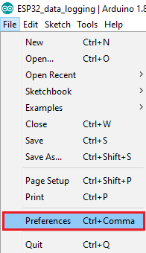

1. Enter **https://dl.espressif.com/dl/package_esp32_index.json** into the “Additional Board Manager URLs” field as shown in the figure below. Then, click the “OK” button:

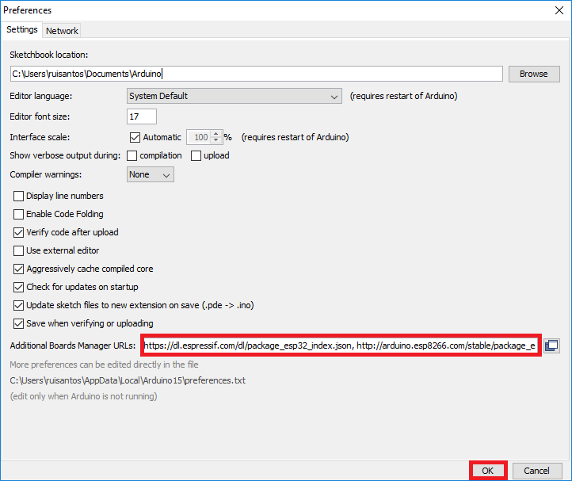

**Note:** if you already have the ESP8266 boards URL, you can separate the URLs with a comma as follows:

https://dl.espressif.com/dl/package_esp32_index.json, http://arduino.esp8266.com/stable/package_esp8266com_index.json

1. Open the Boards Manager. Go to **Tools** > **Board** > **Boards Manager…**

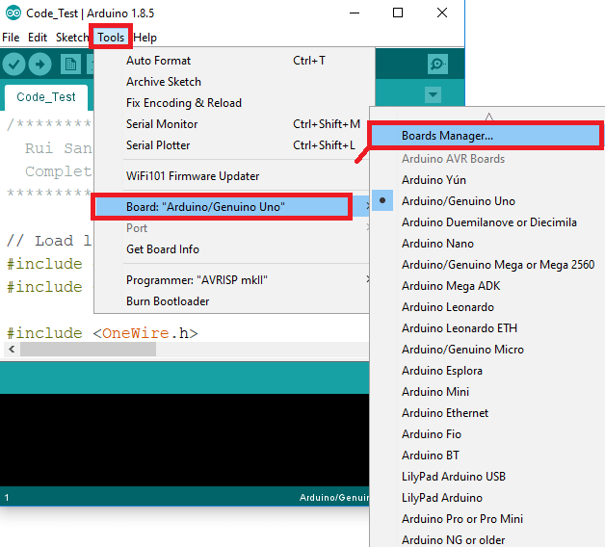

1. Search for **ESP32** and press install button for the “**ESP32 by Espressif Systems**“:

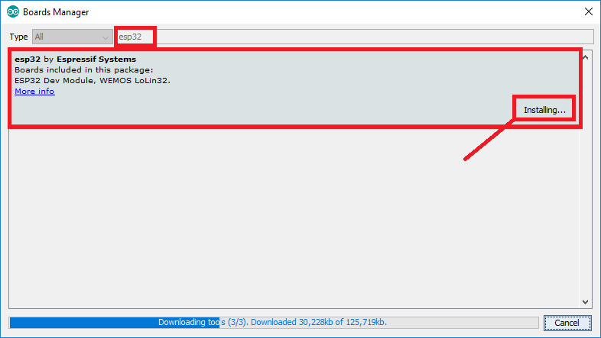

1. That’s it. It should be installed after a few seconds.

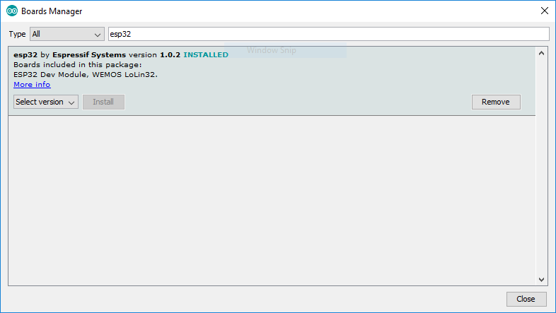

**Testing the Code**

Plug the ESP32 board to your computer. With your Arduino IDE open, follow these steps:

1. Select your Board in **Tools** > **Board** menu (in my case it’s the **DOIT ESP32 DEVKIT V1**)

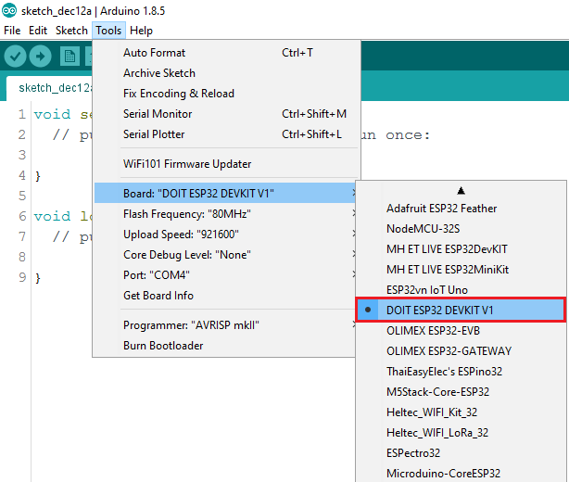

2. Select the Port.

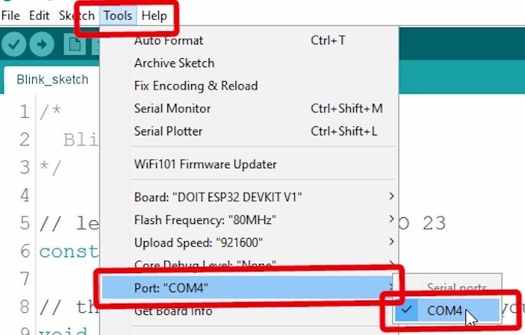

3. Open the code file I provided named send_data.ino.

4. Press the **Upload** button in the Arduino IDE. Wait a few seconds while the code compiles and uploads to your board.

Arduino IDE upload WiFiScan sketch to ESP32

5. If everything went as expected, you should see a “**Done uploading.**” message.

6. Install the app that I provided before with file name app.apk in your android device.

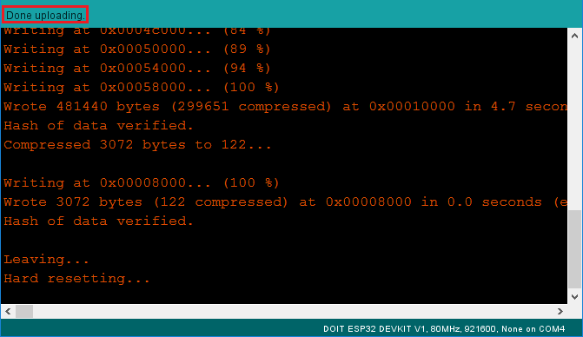

7. Open the Arduino IDE Serial Monitor at a baud rate of 115200:

Open Arduino IDE Serial Monitor at baud rate 115200

8. Now pair the esp32 with android device as you usually pair any Bluetooth device and then open the installed app named DATA SEND. And click the red power button to connect your paired device you will see a device NodeMCU-ESP32 just tap on it if the ESP 32 is connected you will see the red power button color changed to green.

9. Now you are ready to send any message to your ESP32 and you will see the received DATA in Serial Monitor.

This is The Serial Monitor you will see your sent data here

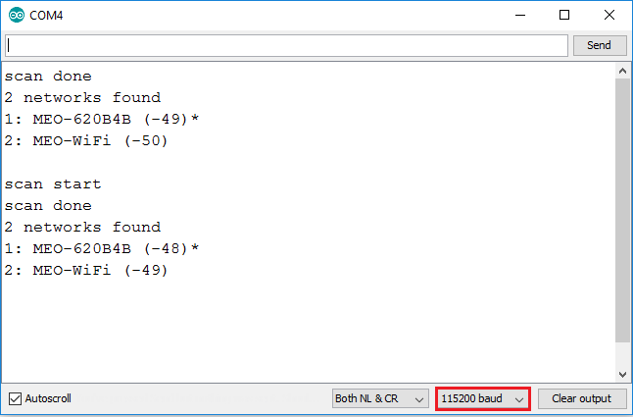

Thanks.